TUTORIAL 1
NAME: AKSHAT AGARWAL
REGISTRATION NUMBER: RA2411042010060
DEPARTMENT: CSBS
SEMESTER: 2ND SEMESTER

Scenario 1: Pointers to Class Members
You’re developing a vehicle management system with a class Vehicle that has several data members (for example, an integer speed and a float fuel Level and a member function display Status. Parts of the system need to dynamically modify and display these attributes using pointers to class members.

(a) How would you declare a pointer to the speed data member and a pointer to the member function display Status?
(b) Provide a code snippet that uses these pointers to set the speed of a Vehicle object and then calls display Status.
(c) What are some potential pitfalls when using pointers to class members, and how can they be mitigated?

SOLUTIONS:
PART A
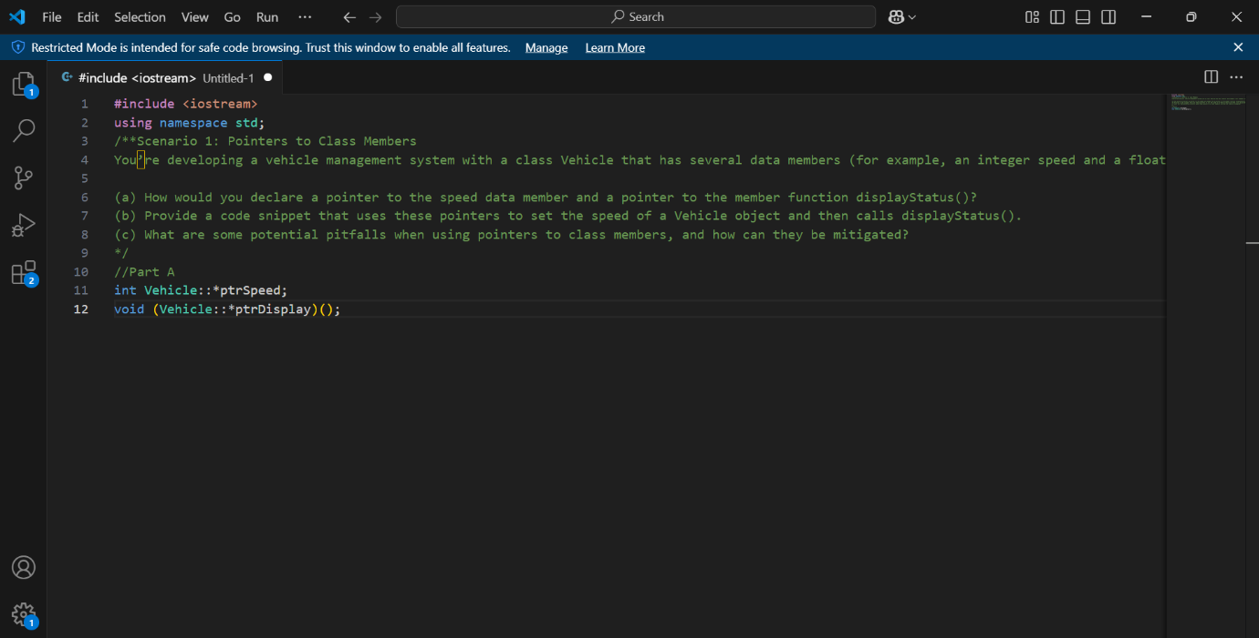

PART B
SOLUTION
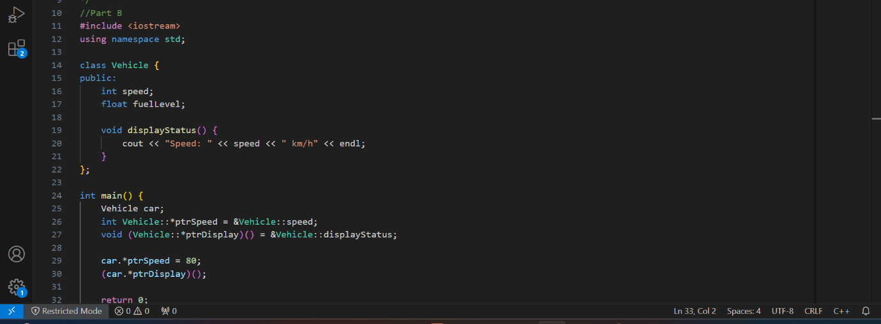

PART C
SOLUTION:
(c)
Potential pitfalls:

Uninitialized Pointers: Using an uninitialized pointer can cause undefined behavior. Always initialize them.

Null Pointer Dereference: If the pointer is not assigned properly, dereferencing it will cause a crash. Check before using it.

Pointer to Member of Different Class: Ensure that the pointer matches the correct class, as using it with another class leads to errors.

Complex Syntax: Pointers to members have a special syntax (.* and ->*), which can be confusing. Use them carefully.

Mitigation:

Always initialize the pointer before using it.

Use smart pointers if dynamic allocation is involved.

